EXERCISE 6
- Order all employees on the basis of the salary they draw.
Query: SELECT * FROM employee_data ORDER BY salary;
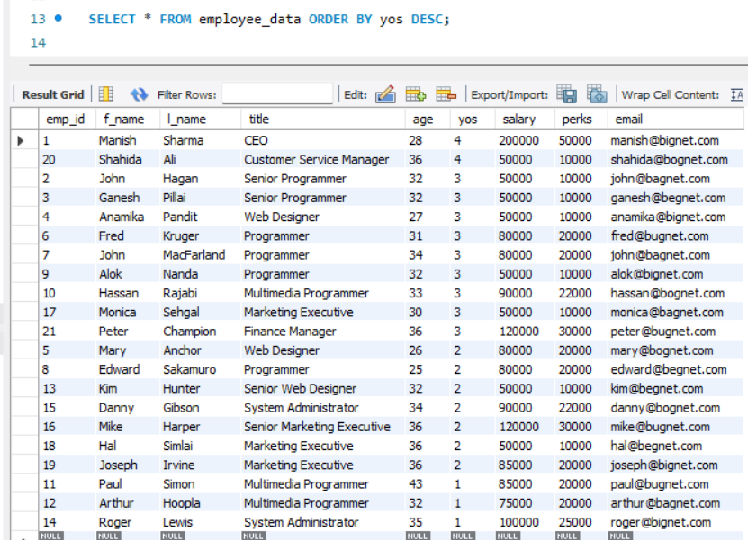
- List all employees in descending order of their years of service.

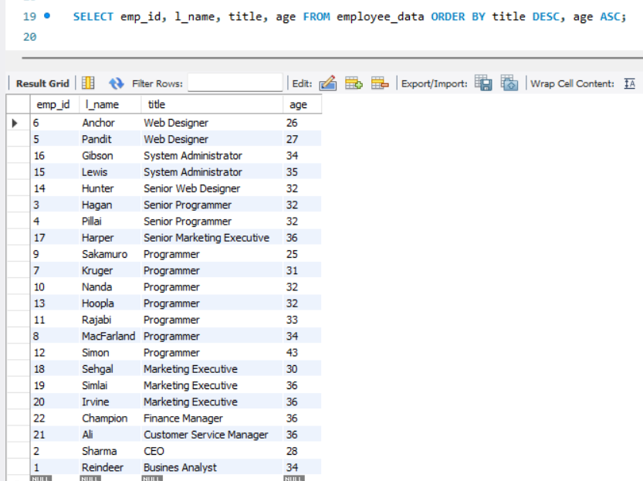
- What does the following statement display?

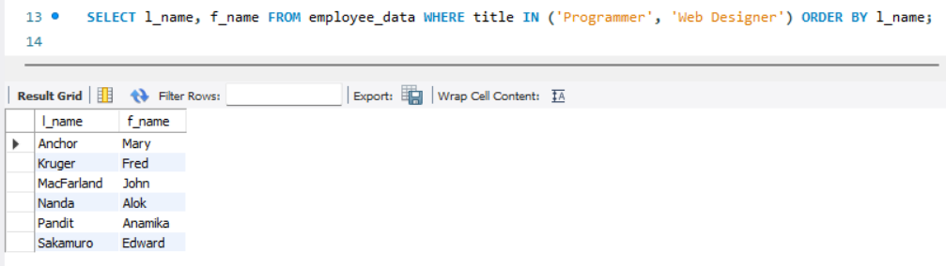
- Display employees (last names followed by first names) who hold the title of either “Programmer” or “Web Designer” and sort their last names alphabetically.

